OSPF Redistribution

In this lab we will configure redistribution of different routes into OSPF and RIP. We will introduce filtering using route-map.
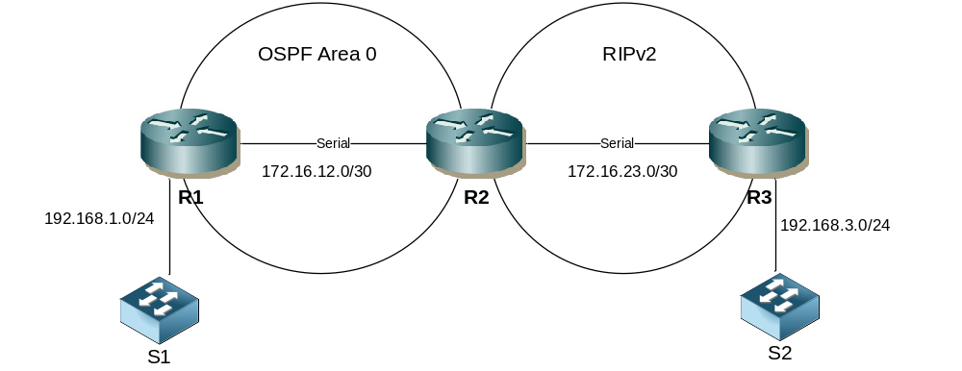

Step 1 - Physical
- Cable up the lab network as per the topology diagram.
- The routers can be 1841 or 1941 models.
- Use serial or Ethernet cables between the routers. If using serial, you decide which end will be DCE.

Step 2 – IP addressing
- Configure IP addressing as follows. You decide on the actual device addresses
R1 LAN | 192.168.1.0/24
R1 – R2 Serial | 172.16.12.0/30
R2 – R3 Serial | 172.16.23.0/30
R3 LAN | 192.168.3.0/24

Step 3 – Configure OSPF
- Set the router-ids to be x.x.x.x where x is the router number.
- Ensure the correct interfaces are running OSPF between R1 & R2.
- Make all LAN interfaces passive.

R1
router ospf 1
router-id 1.1.1.1
network 172.16.12.1 0.0.0.0 area 0
network 192.168.1.1 0.0.0.0 area 0
passive-interface g0/0 *note R1s interface connected to switch

R2
router ospf 1
router-id 2.2.2.2
network 172.16.12.2 0.0.0.0 area 0

Step 4 – Configure RIP
- Configure RIPv2 between R2 & R3
- Ensure auto summarization is disabled

R2 & R3
router rip
version 2
network 172.16.23.0
no auto-summary

Step 4 – Add static routes to R1

- Configure the following static routes on R1
R1(config)#ip route 200.2.0.0 255.255.255.0 null 0
R1(config)#ip route 200.2.1.0 255.255.255.0 null 0
R1(config)#ip route 200.2.2.0 255.255.255.0 null 0
R1(config)#ip route 200.2.3.0 255.255.255.0 null 0
R1(config)#ip route 100.1.1.0 255.255.255.240 null 0
R1(config)#ip route 100.1.1.16 255.255.255.240 null 0
R1(config)#ip route 100.1.1.32 255.255.255.240 null 0
R1(config)#ip route 100.1.1.48 255.255.255.240 null 0

Step 4 – Redistribute the statics into OSPF
- Redistribute the statics into OSPF
- Ensure to include subnets
- Confirm the routes are present in R2s route table
- What type of OSPF routes are these?
R1
router ospf 1
redistribute static subnets

Step 5 - Configure loopback addresses on R3
- Configure the following loopback interfaces and IP addresses on R3
lo0 | 32.10.10.1/24
lo1 | 32.20.20.1/24
lo2 | 32.30.30.1/24
lo3 | 32.30.30.1/24

e.g
interface lo0
ip address 32.10.10.1 255.255.255.0
no shut

Step 6 Redistribute the loopbacks into RIP
- Set a default metric of 5 under RIP on R3
- Redistribute the loopback addresses into RIP on R3
- Confirm the routes are present in R2s route table
- What is the metric for these routes on R2?

router rip
default-metric 5
redistribute connected

Step 7 Redistribute OSPF into RIP on R2
- Configure a default metric under RIP of 3
- Redistribute OSPF into RIP on R2
- Confirm the routes are present on R3

router rip
default-metric 3
redistribute ospf 1

Step 8 Redistribute RIP into OSPF on R2
- Redistribute RIP into OSPF on R2, include subnets, set a metric of 50 and change the external type to 1 within the same redistribution command
- Confirm the routes are present on R3
- What are the cost of the routes on R3

router ospf 1
redistribute rip metric 50 metric-type 1 subnets

Step 9 Use a route-map to filter static route redistribution
- Create a route-map on R1 that matches only the static route networks starting with 200 (hint match a standard ACL)
- Change the redistribute static command on R1 to include the route-map
  - Note this may require clearing the OSPF process
- Confirm the static routes starting with 100 are no longer present on R2

route-map static2ospf permit 10
match ip address 1

ip access-list 1 permit 200.0.0.0 0.255.255.255

router ospf 1
redistribute static route-map static2ospf subnets

clear ip ospf process

Step 10 Use a route-map to filter loop back redistribution
- Create a route-map on R3 that matches only lo1 & lo2
- Change the redistribute static command on R3 to include the route-map
- Confirm the routes for networks matching lo0 & lo3 are no longer present on R2

route-map connected2rip permit 10
match interface lo1 lo2

router rip
redistribute connected route-map connected2rip

or

route-map connected2rip permit 10
match ip address 2

ip access-list 2 permit 32.20.20.0 0.0.0.255
ip access-list 2 permit 32.30.30.0 0.0.0.255

router rip
redistribute connected route-map connected2rip

Challenge
- Change the redistribution of OSPF into RIP on R2 so that a tag value of 666 is applied to all redistributed routes.
- Change the redistribution of RIP into OSPF on R2 so that routes with a TAG value of 666 are not permitted.

